WD Red Pro NAS Hard Drive - 2TB

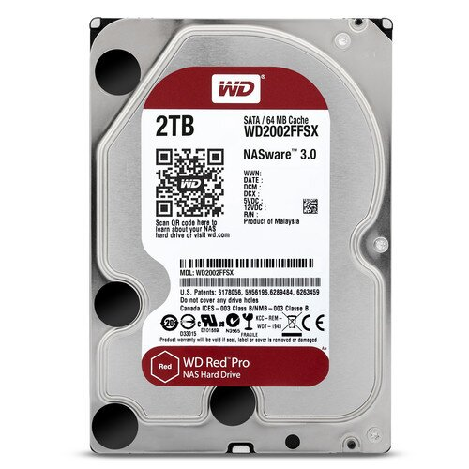

**Key Features**

* **Model**: WD Red Pro
* **Capacity**: 2TB
* **Form Factor**: 3.5-inch
* **Interface**: SATA III (6 Gb/s)
* **Drive Type**: Internal Hard Drive
* **Cache**: 128MB
* **RPM (Revolutions per Minute)**: 7200 RPM

**Data Protection and Security**

* **Advanced Error Recovery**: The WD Red Pro hard drive is equipped with **advanced error recovery controls**, ensuring the safety of data during unexpected power losses or data transmission errors. This enhances the stability of the drive in RAID environments.

**Warranty and Support**

* **Limited Warranty**: The WD Red Pro 2TB comes with a **5-year limited warranty**, offering long-term peace of mind for users who rely on the drive for critical business and personal data storage.
* **Customer Support**: WD provides comprehensive customer support through online resources, including FAQs, troubleshooting guides, and driver downloads.